

**CSF 3133**

**WEB-BASED INTERFACE DESIGN**

**LAB REPORT 1**

NAME: NIK MARIYAH SOFEAH BINTI MOHD RIZAN

MATRIC NUMBER: S76237

LECTURER: PROF. MADYA TS. DR WAN NURAL JAWAHIR HJ WAN YUSSOF

DATE: 22/10/2025

**1.4. Structure of an HTML Document**

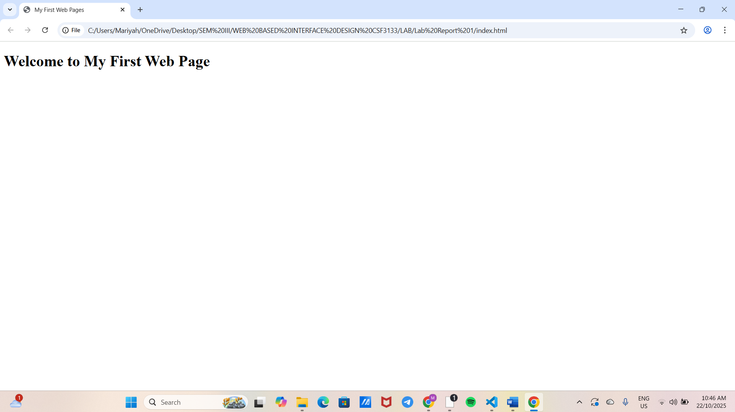

**1.5. Basic HTML Tags**

1.5.1. Headings

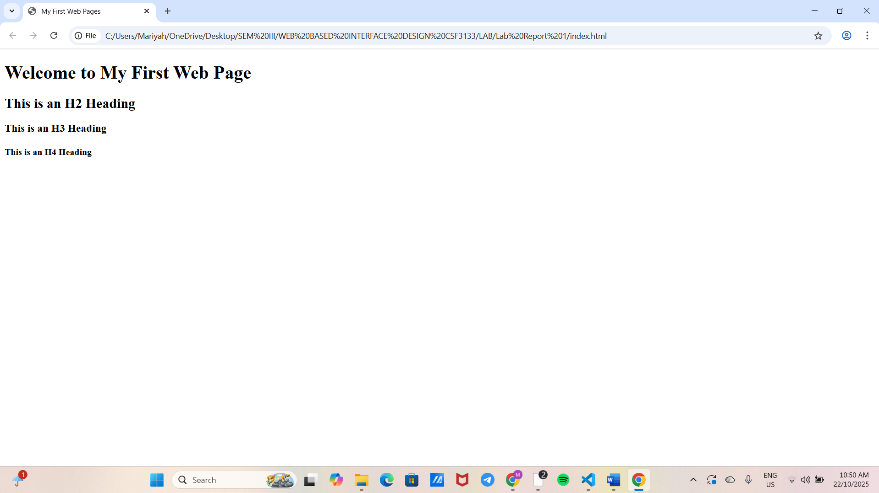

1.5.2. Paragraph and Text Formatting

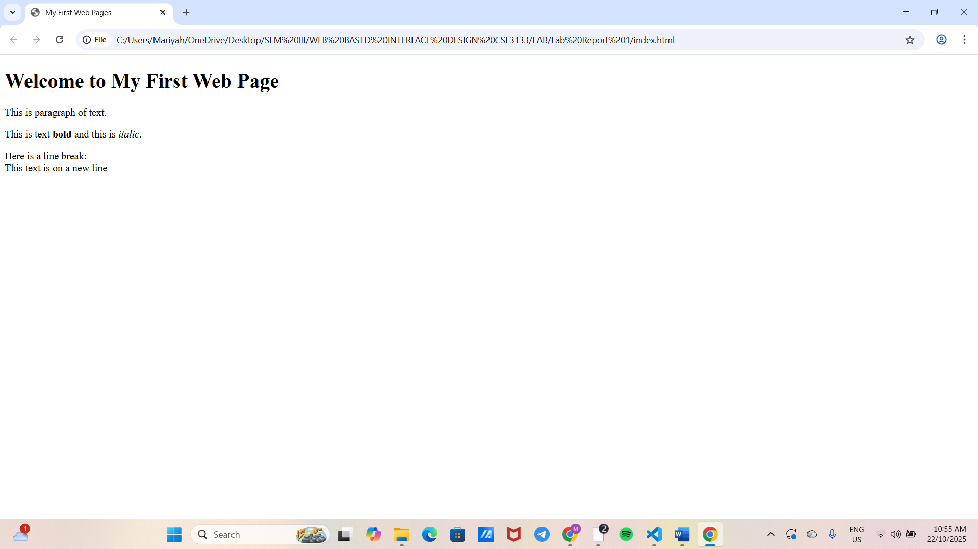

1.5.3. Lists (Ordered and Unordered)

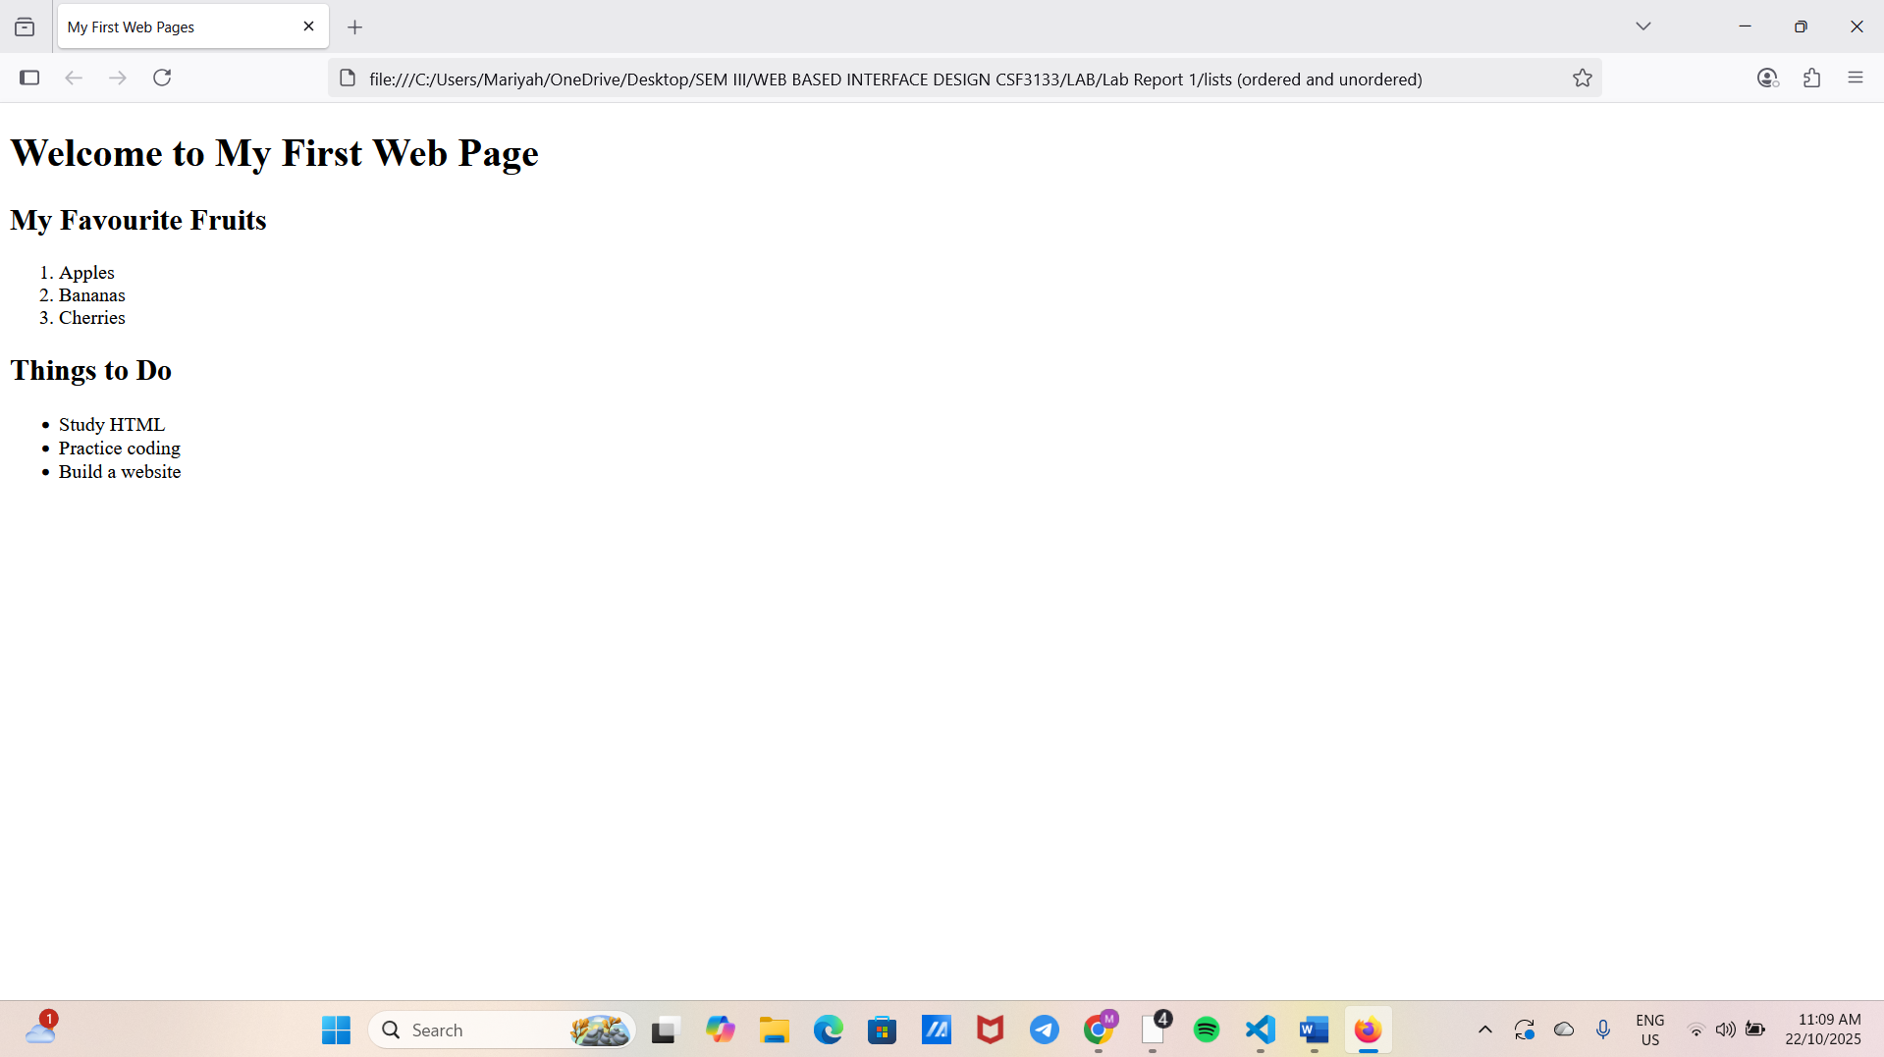

**1.6. Links and Images**

1.6.1. Hyperlink

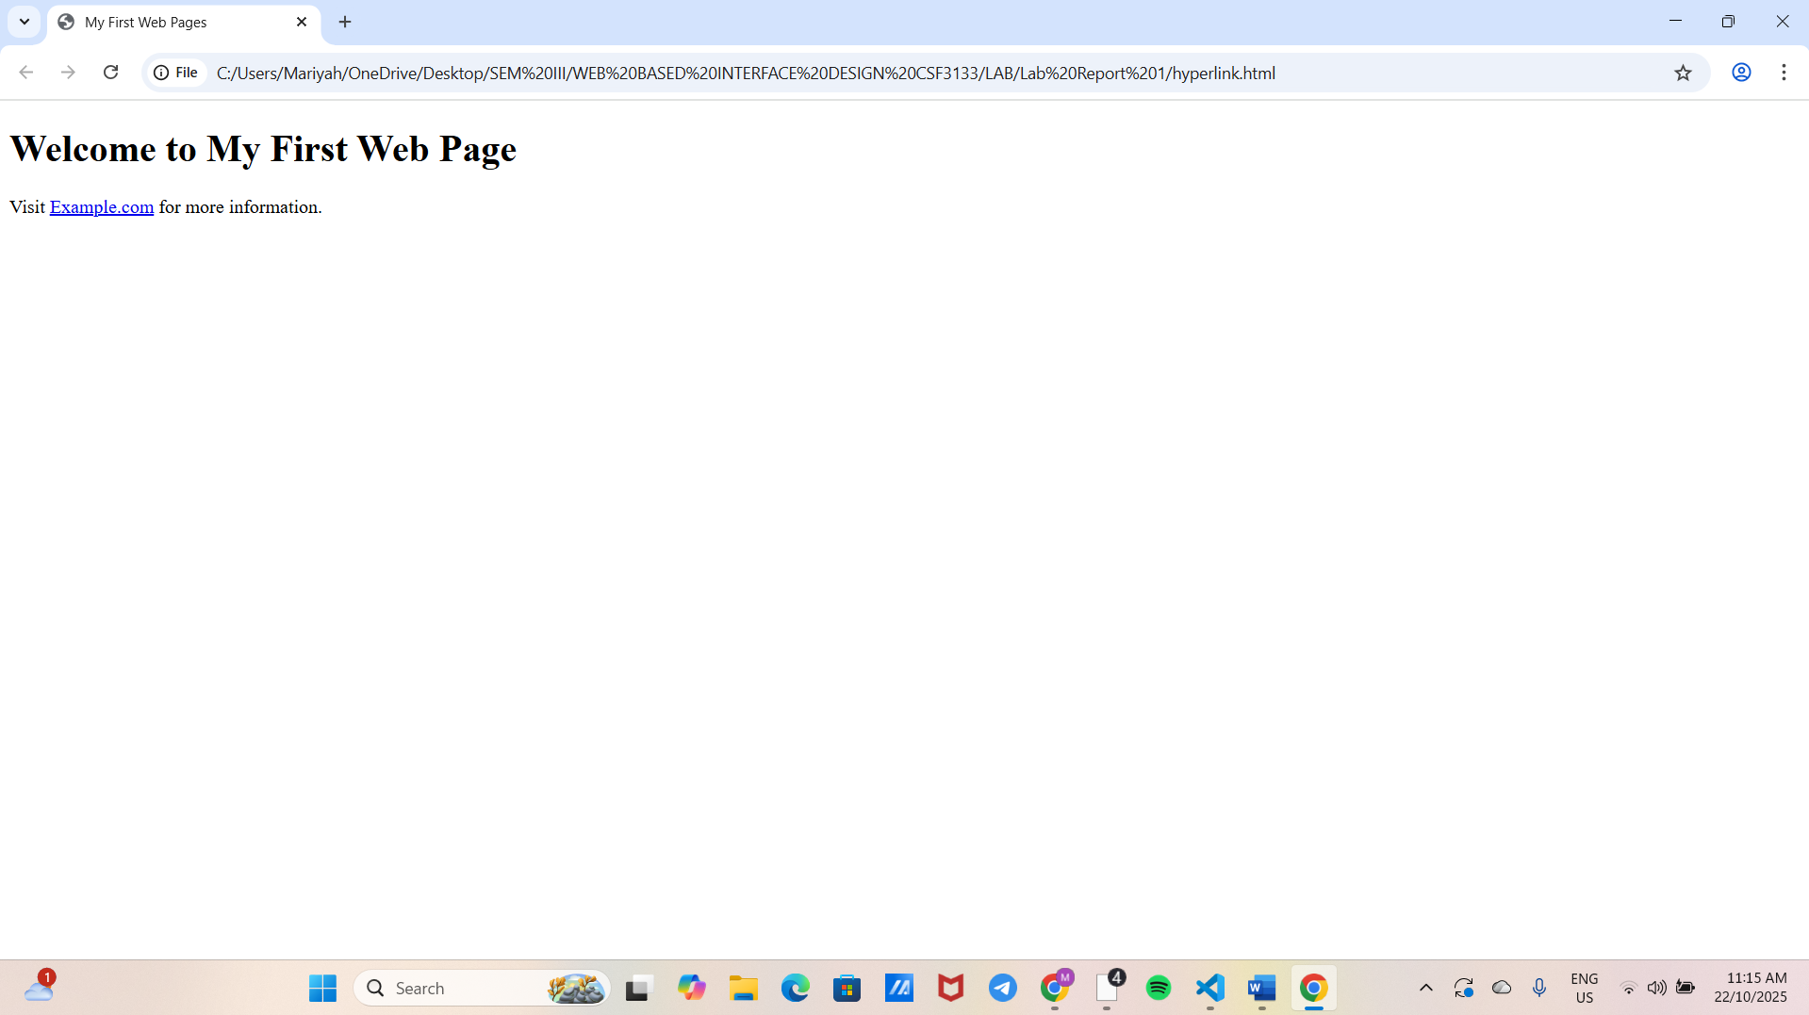

1.6.2. Image

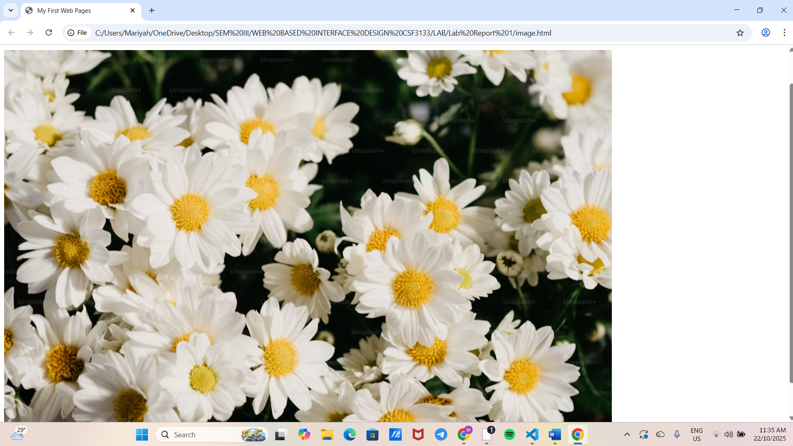

1.6.3. Commenting

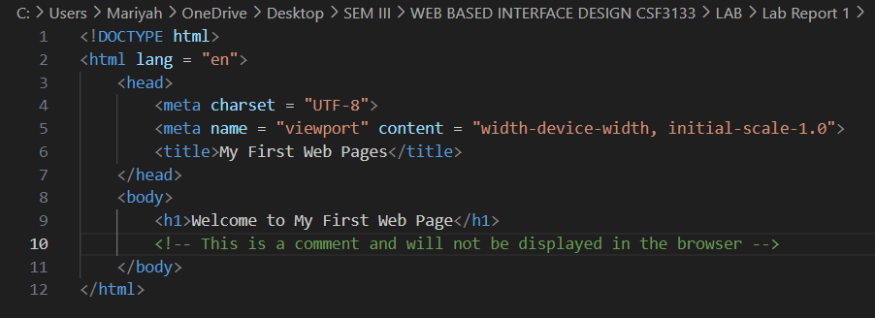

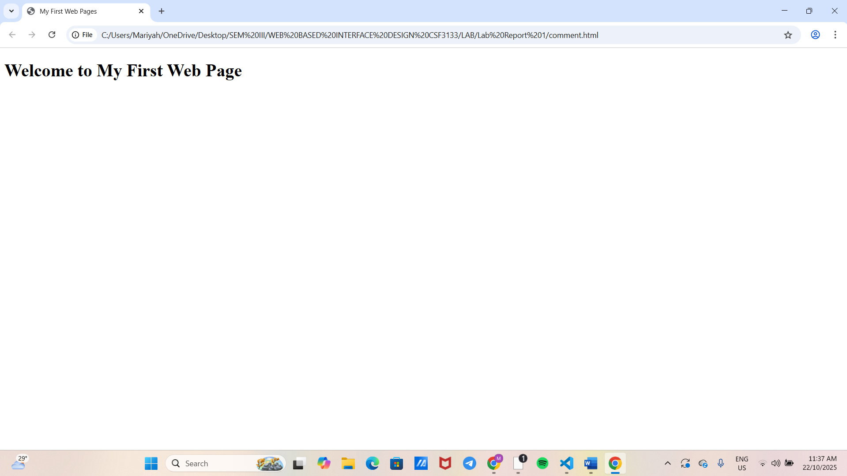

**Lab Exercise**

Source code

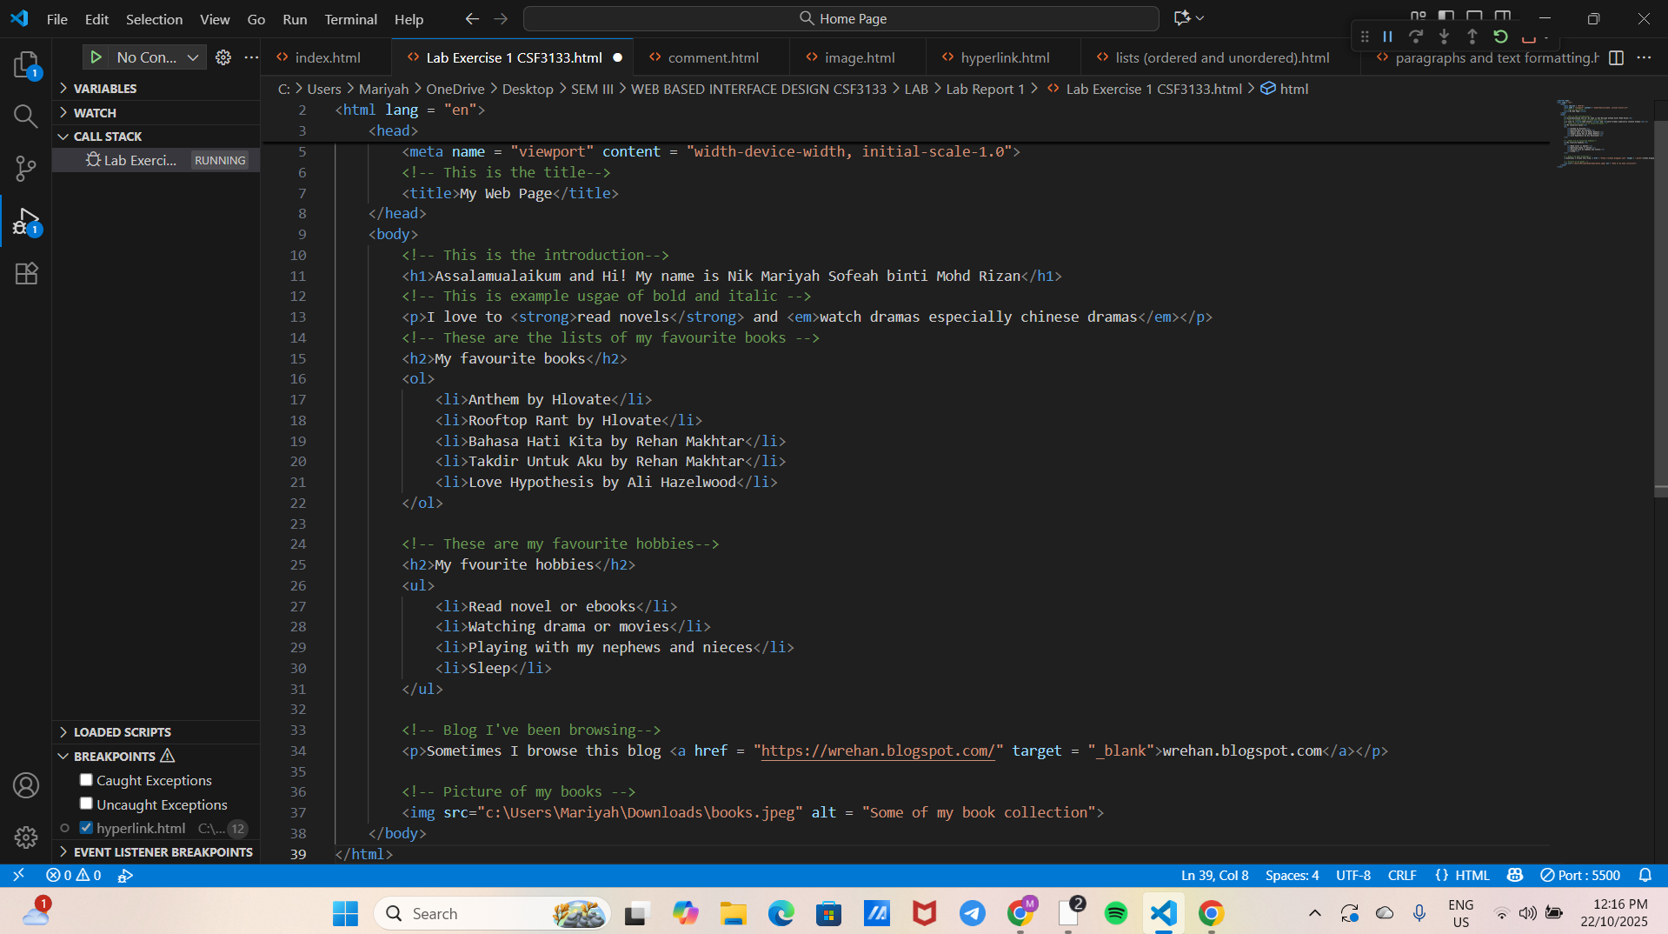

Output

